
Faculty of Engineering
Compute Organization & Architecture
Laboratory Manual

NAME :…………………………………………………………………………………………………………
ENROLLMENT NUMBER :…………………………………………………………………………..
SUBJECT NAME :………………………………………………………………………………………..
SUBJECT CODE :………………………………… BRANCH :……………………………………
SEMESTER :……………………… ACADEMIC YEAR :…………………………………………………

ISBN Number
Swaminarayan university publication



Certificate
This is to certify that Mr. / Ms. / Mrs. …………………………….……………………………… having enrollment number ……………………………………… of ….............. Semester ME/BE/DIPLOMA in …………..………..………..………..……….. has satisfactorily completed his term working (Subject name :…………………………………….....) (subject code :…………..) during academic year…………..... at Faculty of Engineering, Swaminarayan University.

Place : ……………….
Date : ….....................

KHUSHBU GOSWAMI RADHIKA GOKANI DR.BHAVANA SONI
SUBJECT IN-CHARGE HOD DEAN

List of Practical

Sr. No. | Title | Page No. | Date | Sign
1 | Outline intel processor evolution | 4
2 | Prepare 8085 Microprocessor architecture in diagram and explain it. | 13
3 | Summarize out Data Transfer Instructions and perform minimum 3 to 5 programs associated with the said concept | 17
4 | Summarize Arithmetic Instructions of 8085 with example and execute minimum 3 to 5 programs associated with said concept. | 21
5 | Summarize Logical Instructions of 8085 with example and execute minimum 3 to 5 programs associated with said concept. | 23
6 | List Input-Output Instructions of 8085 with example and execute minimum 3 to 5 programs associated with said concept. | 26
7 | List Branching and Looping instructions of 8085 with example and execute basic 2-3 programs associated with said concept. | 30
8 | Make a small poster to represent all types of memory in Memory Hierarchy. | 34
9 | Paraphrase Associative Memory in details Paraphrase Associative Memory in details | 37
10 | Differentiate Programmed I/O and Interrupt initiated I/O in detail. | 40

Practical:-1
Aim:- Outline intel processor evolution.

INTRODUCTION
The first Intel processor debuted in 1971, 20 years before the World Wide Web provided a compelling reason to bring computers into our homes and offices. Intel now offers four processor ranges, from the affordable Celeron to the network-focused Xeon. Technology has helped Intel processors shrink in size, with today’s products made using process technologies of just 10 nanometers. Over the last 55 years, Intel Corporation has played a central role in the computing sector. Founded in California long before the state became the spiritual home of tech firms, Intel is now the world’s largest semiconductor chip manufacturer. Without processors, computers wouldn’t work. Intel has been the dominant force in developing the global computing industry, the growth of the internet and modern-day reliance on cloud services

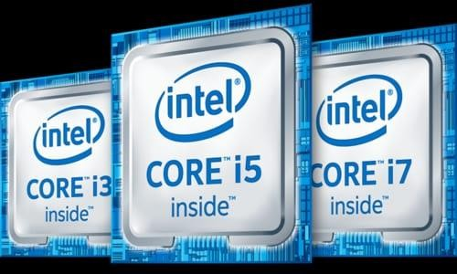
Intel Processors:
In today’s world processors are widely used in electronic devices. Such as mobile phones, computers, laptops, and many other devices. Their performance, processing capacity, and accessibility have grown over the last 5 to 6 decades. There are many manufacturers of computer processors but the Intel processors are more popular
because of their processing results and variety of processor capacity. In the context of such rapid development, it is interesting to find the way of Intel processor evolution. For this, one needs to be able to estimate the influence of changing some characteristics of a processor on its performance. The first microprocessor was made by sir Federico Figgins in 1971. The 4004 was the first complete CPU on a single chip, packaged in a 16-pin ceramic dual in-line package. The 4004 was initially released with a clock speed of 108 kHz (and scaled up to 740

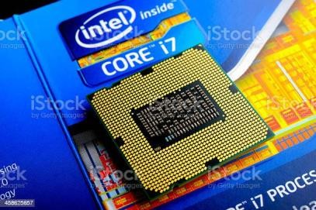
kHz). Produced in a 10 μm (10,000 nm) process, the 4004 had 2,300 transistors and delivered a performance of 0.07 MIPS. The 8-bit 8008 replaced the 4004 in 1972 with 0.5 to
0.8 MHz clock speed and 3,500 transistors and was primarily used in the TI 742 computer. The 8080 followed in 1974 with 4,500 transistors in 6,000 nm with up to 2 MHz It became famous for being used in the Altair 8800, Nowadays
designers must have a real model and set of benchmarks to estimate the performance of the developed processor. It requires some time to prepare the physic model of the processor and spend time calculating in this paper, we consider the evolution of Inter processors over the last 50 years.

History of Intel processor:

Name | Year of Invention | Clock speed | Number of transistors | Inst. Per sec
INTEL 4004/4040 | 1971 by Ted Hoff and Stanley | 740 kHz | 2300 | 60,000

Size of the processor-8bit

Name | Year of Invention | Clock speed | Number of transistors | Inst. Per sec
8008 | 1972 | 500kHz | 3500 | 50,000
8080 | 1974 | 2MHz | 6000 | 10 times faster  than 8008
8085 | 1976 | 3MHz | 6500 | 769230

Size of the processor-16bit

Name | Year of Invention | Clock speed | Number of transistors | Inst. Per sec
8086 | 1978(multiply and divide instruction,16-bit data bus and 20-bit address bus) | 4.77MHz,8MHz,  10MHz | 29000 | 2.5 million
8088 | 1979(cheaper version of 8086  and 8-bit external bus) |  |  | 2.5 million
80186/80188 | 1982(80188  cheaper version of 80186) | 6MHz
80286 | 1982(data bus 16- bit, address bus 64 bit) | 8MHz | 134000 | 4 million

Size of the processor-32bit

Name | Year of Invention | Clock speed | Number of transistors | Inst. Per sec
INTEL 80386 | 1986(other version of 80386DX,80386SX and  32-bit data bus and address bus | 16MHz-  33MHz | 275000
INTEL 80486 | 1986(another version of 80486DX, 80486SX  etc.) |  |  | 8 KB of catch memory
PENTIUM | 1993 |  | 66MHz | Cache memory 8 bit for 8-bit  data

Size of the processor-64bit

Name | Year of Invention | Clock speed | Number of transistors | Inst. Per sec
INTEL  Core 2 | 2006 | 1.2 GHz -3GHz | 291 million transistors | 64 KB of L1  cache per core 4 MB of L2 cache
I3,i5,i7 | 2007,2009,2010 | 2.2GHz-  3.3GHz,2.4GHz-  3.6GHz,2.93GHz-  3.33GHz

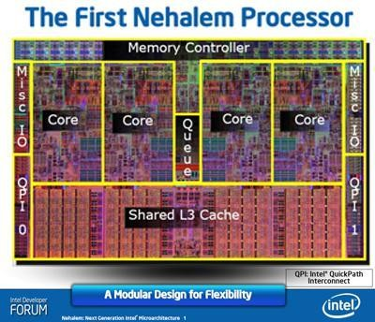
Generation of Intel Processors:
Nehalem – 1st Gen Intel processors (2008)
Process Size: 45nm
Transistors: 731 million to 2300 million Clock speed: 1.06 GHz to 3.33 GHz RAM: 2-channel DDR3-1066
Intel turbo boost 1.0

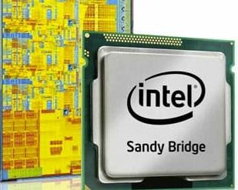
Sandy Bridge – 2nd Gen Intel processors (2011)
Process Size: 32nm
Transistors: 504 million to 2.27 billion Clock speed: 1.60GHz to 3.60 GHz RAM: 2-channel DDR3
Intel Turbo boost 2.0.

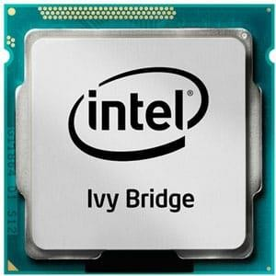
Ivy Bridge – 3rd Gen Intel processors (2012)
Process Size: 22nm Transistors: 2104 million
Clock speed: 1.4GHz to 4.1 GHz RAM: DDR3-1333 to DDR3-1600
Intel Turbo boost 2.0

Haswell – 4th Gen Intel processors (2013)

: Process Size: 22nm
Transistors: 1.4 billion to 5.56 billion Clock speed: 1.1GHz to 4.4 GHz
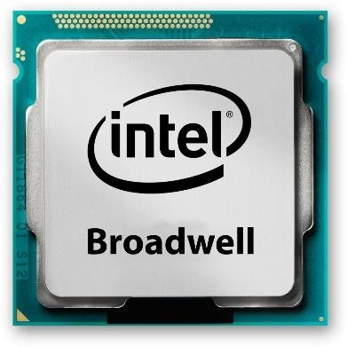
RAM: Dual channel DDR3/ DDR3L, DDR4Intel Turbo boost 2.0

Broadwell-5th Gen Intel processors (2014)
Process Size: 14nm Transistors: 1.9 billion
Clock speed: 1.2GHz to 4GHz
RAM: DDR3, DDR3L, DDR4, Intel Turbo boost 3.0

Skylake – 6th Gen Intel processors (2015)
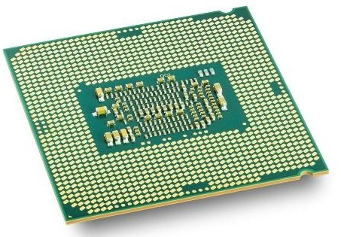
In 2015, Intel designed their Broadwell processor and called them 6th generation, Skylake CPUs. Skylake redesign changes brought greater CPU and GPU performance improvements even more power efficiency. Those changes were also carried out to upcoming generations of Intel processors.
Process Size: 14nm Transistors: 1.9 billion Clock speed: up to 4.5GHz RAM: DDR3, DDR…

Kaby Lake – 7th Gen Intel processors (2016)
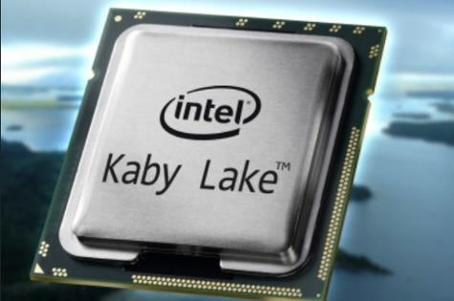
Process Size: 14nm
Clock speed: 1.0GHz to 4.5GHz
RAM: DDR3, DDR3L, DDR4(upto 64GB)
Intel Turbo boost 3.

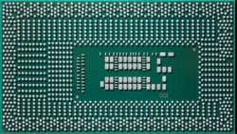
Kaby Lake R – 8th Gen Intel processors (2017)
Process Size: 14nm
Clock speed: 1.0GHz to 4.5GHz RAM: DDR3, DDR4(up to 64GB)
Intel Turbo boost 3.0

Coffee Lake Refresh – 9th Gen Intel processors (2017)
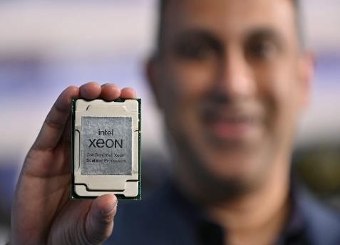
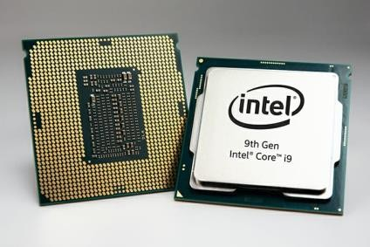
Process Size: 14nm
Clock speed: 1.8GHz to 5GHz
RAM: DDR4-2666 2-
channel up to 128 GB GPU: GT2, GT3e
Intel Turbo boost 3.0

Comet Lake/Ice Lake – 10th Gen Intel processors (2019)
Process Size: 14nm(desktop)/10nm(mobile)
Clock speed: up to 5.3 GHz(desktop)/ 4.1 GHz(mobile) RAM:Up to LPDDR4X at 3733 MHz,
Intel Turbo boost 3.0

Tiger Lake/Rocket Lake – 11th Gen Intel processors (2021)
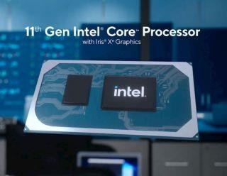
Process Size: 14nm(desktop)/10nm(mobile)
Clock speed: up to 5.3 GHz(desktop)/ 5 GHz(mobile) RAM: DDR4-3200/LPDDR5-5400
Intel Turbo boost 3.0

Alder Lake – 12th Gen Intel processors(2021)
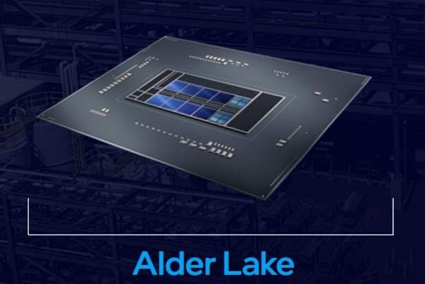
Intel is currently working on 12th generation Alder Lake processors. They will be released at the end of 2021(not an official date). Alder Lake will bring a new LGA 1700 socket along with PCIe 5.0, LPDDR5 RAM, and DMI 4.0 support. It could possibly be a redesign on 10nm architecture, however, most of the details about them are currently unknown.

Alder Lake (Today’s processor):
Alder Lake has finally arrived to the market and we now have our reviews of the leading- edge Core i9-12900K, Core i7-12700K, and Core i5-12600K, and Core i5-12400 with all of the performance benchmarks and analysis. Overall, the Core i5-12600K is now the Best CPU for gaming on the market, while the Core i7-12700K slots in as the best high-end processor for mainstream platforms.


Product details
Brand-AMD
CPU Manufacturer-AMD CPU Model-AMD Ryzen 7 CPU Socket-Socket AM4 Platform-Linux, Windows Secondary Cache-100 MB

Alder Lake has finally arrived to the market and we now have our reviews of the leading-edge Core i9-12900K, Core i7-12700K, and Core i5- 12600K, and Core i5-12400 with all of the performance benchmarks and analysis. Overall, the Core i5-12600K is now the Best CPU for gaming on the market, while the Core i7- 12700K slots in as the best high-end processor for mainstream platforms.

 | General information
Launched Marketed by Designed by  Common manufacturer Product code |  | November 4,2021 Intel  Intel Intel 80715
Performance

Max.CPU clock rate 1.0GHz to 5.5 GHz, P-core
700 MHz to 4.0 GHz, E-cores

Cache

L1 cache 80KB, per P-core
96KB, per E-core
L2 cache 1.25 MB per P-core
2 MB per E-core-modules
L3 cache Up to 30 MB

Application:
Retail-Enable capabilities at ATMs or intelligent vending machines, object detection for cashier-free checkout and audience analytics. High resolution graphics and media deliver stunning next-gen video walls.
Industrial manufacturing-Higher performance platform with TDP ranges for applications like Industrial PCs, Human Machine Interfaces. AI capabilities also deliver fast/accurate machine vision.

Types of Intel processors :
Intel makes many processors designed for different computers and functions. From power- saving processors for netbooks to high-end, multiple-core 64-bit processors, understanding the differences in the processors is key to selecting the right one for your computing purposes.

Atom
Intel Atom processors are low-power-consumption processors designed for use in netbooks and other networked-based computing devices where battery life and power consumption are more important than processing power. There are several types of Atom processor.
Processors without a letter designator before the number are meant for general low-power devices. Processors with a N designator are designed for netbooks. Atom processors designed
for mobile Internet devices have a Z designator. The number following the designator indicates the level of processor. Higher numbers indicate more processor features.

Celeron
Celeron processors are designed for lower-end desktop computers that are primarily used for web activities and basic computing. Celeron processors have a numerical indicator. The higher the number, the more features on the processor. There are different classes of Celeron processors, including lower-power consumption processors designed for laptop computers.

Pentium
Pentium has been used as a name for a number of different generations of processors. Current generation Pentium processors are energy-efficient dual core processors designed for desktop computers. Pentium processors have numeric designators that, like other Intel processors, indicate higher levels of features with higher-series numbers.

Core
There are two types of Core processors. The original Core processor is called the i7. The number following the i7 on the CPU indicates the number of CPU features. A higher number indicates more features, like cache, clock speed, front side bus or other technologies. Core 2 Duo processors are multiple-core processors.

Xeon and Itanium
Intel Xeon and Itanium processors are server class CPUs designed and optimized for various server applications. These processors have three letter indicators: X indicates a high- performance CPU, E indicates a rack-optimized CPU, and L indicates a power-optimized CPU. There are three levels of Xeon processors. The 3000 series processors contain a single core, 5000 series processors contain two cores, and 7000 series processors contain more than two cores. The 9000 series processors indicate Itanium class processors, which can have two or more cores. Higher numbers in each series indicate more processor features

Conclusions
After I've presented all of the findings, I'll be able to draw some conclusions. Tiger Lake/ Rocket Lake is the last microarchitecture to be evaluated. The Tiger Lake microprocessor architecture is the most recent in Intel's CPU history. It is equipped with more advanced features than any previous Intel CPU version. In comparison to previous generations, the tiger lake's functioning and performance are more flexible. It is built with higher-quality components than other Intel processors. We also notice that RAM and cache boost the computer's performance. We've also seen that the number of transistors and registers has increased insignificantly over the last 15 years, so we expect this trend to continue in new processors, with the number of registers vector increasing for higher processing quality. As a result, we can expect the number of internal registers, transistors, and other parts in the next processor microarchitecture to increase in order to improve performance.

References
William Stallings; Computer organization and Architecture
New Challenges in Computer Architecture Education; September 2022; DOI: 10.46793/TIE22.141V
PARAM: The First Super Computer of India; August 2022; DOI: 10.5281/zenodo.7017332

Practical:-2
Aim:- Prepare 8085 Microprocessor architecture in diagram and explain it.
Introduction :
The 8085 microprocessor is an 8-bit microprocessor that was developed by Intel in the mid-1970s. It was widely used in the early days of personal computing and was a popular choice for hobbyists and enthusiasts due to its simplicity and ease of use. The architecture of the 8085 microprocessor consists of several key components, including the accumulator, registers, program counter, stack pointer, instruction register, flags register, data bus, address bus, and control bus.
The accumulator is an 8-bit register that is used to store arithmetic and logical results. It is the most commonly used register in the 8085 microprocessor and is used to perform arithmetic and logical operations such as addition, subtraction, and bitwise operations.
The 8085 microprocessor has six general-purpose registers, including B, C, D, E, H, and L, which can be combined to form 16-bit register pairs. The B and C registers can be combined to form the BC register pair, the D and E registers can be combined to form the DE register pair, and the H and L registers can be combined to form the HL register pair. These register pairs are commonly used to store memory addresses and other data.
The program counter is a 16-bit register that contains the memory address of the next instruction to be executed. The program counter is incremented after each instruction is executed, which allows the microprocessor to execute instructions in sequence.
The stack pointer is a 16-bit register that is used to manage the stack. The stack is a section of memory that is used to store data temporarily, such as subroutine addresses and other data. The stack pointer is used to keep track of the top of the stack.
The instruction register is an 8-bit register that contains the current instruction being executed. The instruction register is used by the microprocessor to decode and execute instructions.
2.
The flags register is an 8-bit register that contains status flags that indicate the result of an arithmetic or logical operation. These flags include the carry flag, zero flag, sign flag, and parity flag. The carry flag is set when an arithmetic operation generates a carry, the zero flag is set when the result of an arithmetic or logical operation is zero, the sign flag is set when the result of an arithmetic or logical operation is negative, and the parity flag is set when the result of an arithmetic or logical operation has an even number of 1 bits.
3.
The data bus is an 8-bit bus that is used to transfer data between the microprocessor and memory or other devices. The data bus is bidirectional, which means that it can be used to read data from memory or write data to memory.
The address bus is a 16-bit bus that is used to address memory and other devices. The address bus is used to select the memory location or device that the microprocessor wants to access.
4.
The control bus is a set of signals that controls the operations of the microprocessor, including the read and write operations. The control bus includes signals such as the read signal, write signal, interrupt signal, and reset signal. The read signal is used to read data from memory or other devices, the write signal is used to write data to memory or other devices, the interrupt signal is used to signal the microprocessor that an interrupt has occurred, and the reset signal is used to reset the microprocessor to its initial state.
8085 is an 8-bit, general-purpose microprocessor.
It consists of the following functional units:
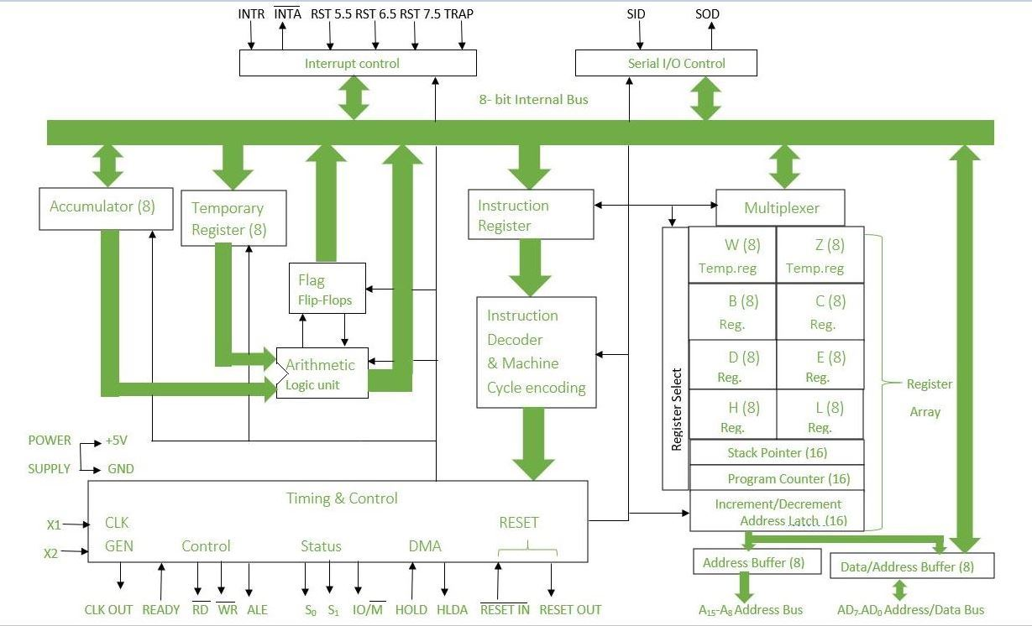

Arithmetic and Logic Unit (ALU) :
It is used to perform mathematical operations like addition, multiplication, subtraction, division, decrement, increment, etc. Different operations are carried out in ALU: Logical operations, Bit-Shifting Operations, and Arithmetic Operations.

Flag Register:- It is an 8-bit register that stores either 0 or 1 depending upon which value is stored in the accumulator. Flag Register contains 8-bit out of which 5-bits are important and the rest of 3-bits are “don’t Care conditions”. The flag register is a dynamic register because after each operation to check whether the result is zero, positive or negative, whether there is any overflow occurred or not, or for comparison of two 8-bit numbers carry flag is checked. So for numerous operations to check the contents of the accumulator and from that contents if we want to check the behavior of given result then we can use Flag register to verify and check. So we can say that the flag register is a status register and it is used to check the status of the current operation which is being carried out by ALU.
Different Fields of Flag Register:
- Carry Flag
- Parity Flag
- Auxiliary Carry Flag
- Zero Flag
- Sign Flag
Accumulator:-Accumulator is used to perform I/O, arithmetic, and logical operations. It is connected to ALU and the internal data bus. The accumulator is the heart of the microprocessor because for all arithmetic operations Accumulator’s 8-bit pin will always there connected with ALU and in most-off times all the operations carried by different instructions will be stored in the accumulator after operation performance.

General Purpose Registers:-There are six general-purpose registers. These registers can hold 8-bit values. These 8-bit registers are B,C,D,E,H,L. These registers work as 16-bit registers when they work in pairs like B-C, D-E, and H-L. Here registers W and Z are reserved registers. We can’t use these registers in arithmetic operations. It is reserved for microprocessors for internal operations like swapping two 16-bit numbers. We know that to swap two numbers we need a third variable hence here W-Z register pair works as temporary registers and we can swap two 16-bit numbers using this pair.

Program Counter :-Program Counter holds the address value of the memory to the next instruction that is to be executed. It is a 16-bit register.

For Example: Suppose current value of Program Counter : [PC] = 4000H
(It means that next executing instruction is at location 4000H.After fetching,program Counter(PC) always increments
by +1 for fetching of next instruction.)
Stack Pointer :-It works like a stack. In stack, the content of the register is stored that is later used in the program. It is a 16-bit special register. The stack pointer is part of memory but it is part of Stack operations, unlike random memory access. Stack pointer works in a continuous and contiguous part of the memory. whereas Program Counter(PC) works in random memory locations. This pointer is very useful in stack-related operations like PUSH, POP, and nested CALL requests initiated by Microprocessor. It reserves the address of the most recent stack entry.

Temporary Register:-It is an 8-bit register that holds data values during arithmetic and logical operations.

Instruction register and decoder:-It is an 8-bit register that holds the instruction code that is being decoded. The instruction is fetched from the memory.

Timing and control unit:-The timing and control unit comes under the CPU section, and it controls the flow of data from the CPU to other devices. It is also used to control the operations performed by the microprocessor and the devices connected to it. There are certain timing and control signals like Control signals, DMA Signals, RESET signals and Status signals.

Interrupt control:-Whenever a microprocessor is executing the main program and if suddenly an interrupt occurs, the microprocessor shifts the control from the main program to process the incoming request. After the request is completed, the control goes back to the main program. There are 5 interrupt signals in 8085 microprocessors: INTR, TRAP, RST 7.5, RST 6.5, and RST 5.5.
Priorities of Interrupts: TRAP > RST 7.5 > RST 6.5 > RST 5.5 > INTR

Address bus and data bus: -The data bus is bidirectional and carries the data which is to be stored. The address bus is unidirectional and carries the location where data is to be stored.
In the 8085 microprocessor, the address bus and data bus are two separate buses that are used for communication between the microprocessor and external devices.
The Address bus is used to transfer the memory address of the data that needs to be read or written. The address bus is a 16-bit bus, allowing the 8085 to access up to 65,536 memory locations.
The Data bus is used to transfer data between the microprocessor and external devices such as memory and I/O devices. The data bus is an 8-bit bus, allowing the 8085 to transfer 8-bit data at a time. The data bus can also be used for instruction fetch operations, where the microprocessor fetches the instruction code from memory and decodes it.
The combination of the address bus and data bus allows the 8085 to communicate with and control external devices, allowing it to execute its program and perform various operations.

Serial Input/output control:-It controls the serial data communication by using Serial input data and Serial output data.
Serial Input/Output control in the 8085 microprocessor refers to the communication of data between the microprocessor and external devices in a serial manner, i.e., one bit at a time. The 8085 has a serial I/O port (SID/SOD) for serial communication. The SID pin is used for serial input and the SOD pin is used for serial output. The timing and control of serial communication is managed by the 8085’s internal circuitry. The 8085 also has two special purpose registers, the Serial Control Register (SC) and the Serial Shift Register (SS), which are used to control and monitor the serial communication.

Practical:-3
Aim:- Summarize out Data Transfer Instructions and perform minimum 3 to 5 programs associated with the said concept.
Data transfer instructions are the instructions that transfer data in the microprocessor. They are also called copy instructions. Here is the following is the table showing the list of logical instructions:
OPCODE | OPERAND | EXPLANATION | No. of bytes | Machine cycles | No. of T-states | EXAMPLE
MOV | Rd, Rs | Rd = Rs | 1 | 1 opcode fetch | 4 | MOV A, B
MOV | Rd, M | Rd = Mc | 1 | 1 opcode fetch  1 memory read | 7 | MOV A, 2050
MOV | M, Rs | M = Rs | 1 | 1 opcode fetch  1 memory write | 7 | MOV 2050, A
MVI | Rd, 8-bit data | Rd = 8-bit data | 2 | 1 opcode fetch  1 memory read | 7 | MVI A, 50
MVI | M, 8-bit data | M = 8-bit data | 2 | 1 opcode fetch  1 memory read  1 memory write | 10 | MVI 2050, 50
LDA | 16-bit address | A = contents at address | 3 | 1 opcode fetch  2 memory reads for 16-bit data  1 memory read for reading content at 16-bit address | 13 | LDA 2050
STA | 16-bit address | contents at address = A | 3 | 1 opcode fetch  2 memory reads  1 memory write | 13 | STA 2050
LHLD | 16-bit address | directly loads at H & L registers | 3 | 1 opcode fetch  2 memory reads for reading 16-bit data  2 memory reads for loading H and L registers | 16 | LHLD 2050
SHLD | 16-bit address | directly stores from H & L registers | 3 | 1 opcode fetch  2 memory reads for reading 16-bit data  2 memory write | 16 | SHLD 2050
LXI | r.p., 16-bit data | loads the specified register pair with data | 3 | 1 opcode fetch  2 memory reads | 10 | LXI H, 3050
LDAX | r.p. | indirectly loads at the accumulator A | 1 | 1 opcode fetch  1 memory read | 7 | LDAX H
STAX | 16-bit address | indirectly stores from the accumulator A | 1 | 1 opcode fetch  1 memory write | 7 | STAX 2050
XCHG | none | exchanges H with D, and L with E | 1 | 1 opcode fetch | 4 | XCHG
XTHL | none | exchanges the content of the top of the stack with the content of HL pair | 1 | 1 opcode fetch  2 memory reads  2 memory writes | 16 | XTHL
PUSH | r.p. | pushes r.p. to the stack | 1 | 1 opcode fetch  2 memory writes | 12 | PUSH H
POP | r.p. | pops the stack to r.p. | 1 | 1 opcode fetch  2 memory reads | 10 | POP H
IN | 8-bit port address | inputs contents of the specified port to A | 2 | 1 opcode fetch  1 memory read  1 I/O read | 10 | IN 15
OUT | 8-bit port address | outputs contents of A to the specified port | 2 | 1 opcode fetch  1 memory read  1 I/O write | 10 | OUT 15
In the table,
R stands for register
M stands for memory
r.p. stands for register pair

Advantages:
Efficient data transfer: The data transfer instructions in the 8085 microprocessor can move data quickly and efficiently between different registers, memory locations, and input/output ports.
Simplifies programming: The data transfer instructions in the 8085 microprocessor simplify programming by providing a set of dedicated instructions for transferring data.
Supports a wide range of operations: The data transfer instructions in the 8085 microprocessor support a wide range of operations, including loading data into registers, storing data in memory locations, and input/output operations.
Can be used for memory operations: The data transfer instructions can be used to transfer data between registers and memory locations, making it possible to store and retrieve data from memory.

Disadvantages:
Limited memory access: Although the use of registers can reduce the number of memory accesses required, the limited number of registers in the 8085 microprocessor can restrict the amount of data that can be manipulated at any given time.
Complex addressing modes: The addressing modes used in the data transfer instructions can be complex, which can make programming more difficult.
Limited I/O port access: The 8085 microprocessor has a limited number of input/output ports, which can restrict the amount of data that can be transferred to external devices.
Limited data size: The 8085 microprocessor uses 8-bit data transfer instructions, which can limit the amount of data that can be transferred in a single instruction. This can be a disadvantage for applications that require large amounts of data to be transferred.

Practical:-4
Aim:- Summarize Arithmetic Instructions of 8085 with example and execute minimum 3 to 5 programs associated with said concept.
Arithmetic Instructions are the instructions which perform basic arithmetic operations such as addition, subtraction and a few more. In 8085 microprocessor, the destination operand is generally the accumulator. Following is the table showing the list of arithmetic instructions:
Opcode | Operand | Explanation | Example
ADD | R | A = A + R | ADD B
ADD | M | A = A + Mc | ADD 2050
ADI | 8-bit data | A = A + 8-bit data | ADI 50
ADC | R | A = A + R + prev. carry | ADC B
ADC | M | A = A + Mc + prev. carry | ADC 2050
ACI | 8-bit data | A = A + 8-bit data + prev. carry | ACI 50
SUB | R | A = A – R | SUB B
SUB | M | A = A – Mc | SUB 2050
SUI | 8-bit data | A = A – 8-bit data | SUI 50
SBB | R | A = A – R – prev. carry | SBB B
SBB | M | A = A – Mc -prev. carry | SBB 2050
SBI | 8-bit data | A = A – 8-bit data – prev. carry | SBI 50
INR | R | R = R + 1 | INR B
INR | M | M = Mc + 1 | INR 2050
INX | r.p. | r.p. = r.p. + 1 | INX H
DCR | R | R = R – 1 | DCR B
DCR | M | M = Mc – 1 | DCR 2050
DCX | r.p. | r.p. = r.p. – 1 | DCX H
DAD | r.p. | HL = HL + r.p. | DAD H
1 Add) – The content of operand are added to the content of the accumulator and the result is stored in accumulator .
with the addition instruction , the following 3 operations can be done.
1) any 8 bit number can be added to the contents of the accumulator and the result is stored in the accumulator.
2) The contents of a register can be added to the contents of the accumulator and result is stored in the accumulator .
3) The contents of a memory location can be added to the contents of the accumulator and result is stored in accumulator.
this 1 byte instruction.
example – addb c it adds the content of accumulator to the content of the register b
2) SUB Any 8 bit data or the contents of a register or contents of a memory location can be subtracted from the contents of the accumulator.
with the subtraction instruction the following 3 operator can be done .
1) any 8 bit number can be subtracted from the contents of the accumulator . The result is stored in the accumulator.
In the table, R stands for register M stands for memory Mc stands for memory contents r.p. stands for register pair

Practical:- 5
Aim:- Summarize Logical Instructions of 8085 with example and execute minimum 3 to 5 programs associated with said concept.

Introduction:
Logical instructions in the 8085 microprocessor are a set of instructions that perform logical operations on data in registers and memory. Logical operations are operations that manipulate the bits of data without affecting their numerical value. These operations include AND, OR, XOR, and NOT.
The logical instructions in the 8085 microprocessor include:
- ANA – Logical AND: This instruction performs a logical AND operation between the accumulator and a specified register or memory location, and stores the result in the accumulator. For example, the instruction “ANA B” performs a logical AND operation between the contents of the accumulator and the contents of the B register.
- ORA – Logical OR: This instruction performs a logical OR operation between the accumulator and a specified register or memory location, and stores the result in the accumulator. For example, the instruction “ORA C” performs a logical OR operation between the contents of the accumulator and the contents of the C register.
- XRA – Logical XOR: This instruction performs a logical XOR operation between the accumulator and a specified register or memory location, and stores the result in the accumulator. For example, the instruction “XRA M” performs a logical XOR operation between the contents of the accumulator and the contents of the memory location pointed to by the HL register.
- CPL – Logical Complement: This instruction performs a logical complement operation on the contents of the accumulator. This operation flips all the bits of the accumulator, effectively reversing its value.
- CMA – Complement Accumulator: This instruction performs a bitwise complement operation on the contents of the accumulator. This operation flips all the bits of the accumulator, effectively reversing its value.
Logical instructions are the instructions that perform basic logical operations such as AND, OR, etc. In the 8085 microprocessor, the destination operand is always the accumulator. Here logical operation works on a bitwise level.
Why use Logical instructions in 8085 microprocessor ?
Here are some specific reasons why logical instructions are used in the 8085 microprocessor:
- Data comparison: Logical instructions can be used to compare two pieces of data bit-by-bit. For example, the XOR instruction can be used to compare the contents of two registers or memory locations and set a flag if they are not equal.
- Data masking: Logical instructions can be used to selectively mask or extract specific bits of data. For example, the AND instruction can be used to mask off all but a specific set of bits, while the OR instruction can be used to set specific bits to 1.
- Data encryption: Logical instructions can be used to perform bitwise encryption of data. By performing a logical XOR between the data and a secret key, the data can be encrypted in a reversible way that can only be decrypted with the same key.
- Decision-making: Logical instructions can be used to make decisions in programs. For example, the AND instruction can be used to test if multiple conditions are true, while the OR instruction can be used to test if at least one condition is true.
Following is the table showing the list of logical instructions:
OPCODE | OPERAND | DESTINATION | EXAMPLE
ANA | R | A = A AND R | ANA B
ANA | M | A = A AND Mc | ANA 2050
ANI | 8-bit data | A = A AND 8-bit data | ANI 50
ORA | R | A = A OR R | ORA B
ORA | M | A = A OR Mc | ORA 2050
ORI | 8-bit data | A = A OR 8-bit data | ORI 50
XRA | R | A = A XOR R | XRA B
XRA | M | A = A XOR Mc | XRA 2050
XRI | 8-bit data | A = A XOR 8-bit data | XRI 50
CMA | none | A = 1’s complement of A | CMA
CMP | R | Compares R with A and triggers the flag register | CMP B
CMP | M | Compares Mc with A and triggers the flag register | CMP 2050
CPI | 8-bit data | Compares 8-bit data with A and triggers the flag register | CPI 50
RRC | none | Rotate accumulator right without carry | RRC
RLC | none | Rotate accumulator left without carry | RLC
RAR | none | Rotate accumulator right with carry | RAR
RAL | none | Rotate accumulator left with carry | RAR
CMC | none | Compliments the carry flag | CMC
STC | none | Sets the carry flag | STC
In the table,
R stands for register
M stands for memory
Mc stands for memory contents

Practical:-6
Aim:- List Input-Output Instructions of 8085 with example and execute minimum 3 to 5 programs associated with said concept.
Following is the table showing the list of Arithmetic instructions with their meanings.
Opcode | Operand | Meaning | Explanation
ADD | R  M | Add register or memory, to the accumulator | The contents of the register or memory are added to the contents of the accumulator and the result is stored in the accumulator.  Example − ADD K.
ADC | R  M | Add register to the accumulator with carry | The contents of the register or memory & M the Carry flag are added to the contents of the accumulator and the result is stored in the accumulator.  Example − ADC K
ADI | 8-bit data | Add the immediate to the accumulator | The 8-bit data is added to the contents of the accumulator and the result is stored in the accumulator.  Example − ADI 55K
ACI | 8-bit data | Add the immediate to the accumulator with carry | The 8-bit data and the Carry flag are added to the contents of the accumulator and the result is stored in the accumulator.  Example − ACI 55K
LXI | Reg. pair, 16bit data | Load the register pair immediate | The instruction stores 16-bit data into the register pair designated in the operand.  Example − LXI K, 3025M
DAD | Reg. pair | Add the register pair to H and L registers | The 16-bit data of the specified register pair are added to the contents of the HL register.  Example − DAD K
SUB | R  M | Subtract the register or the memory from the accumulator | The contents of the register or the memory are subtracted from the contents of the accumulator, and the result is stored in the accumulator.  Example − SUB K
SBB | R  M | Subtract the source and borrow from the accumulator | The contents of the register or the memory & M the Borrow flag are subtracted from the contents of the accumulator and the result is placed in the accumulator.  Example − SBB K
SUI | 8-bit data | Subtract the immediate from the accumulator | The 8-bit data is subtracted from the contents of the accumulator & the result is stored in the accumulator.  Example − SUI 55K
XCHG | None | Exchange H and L with D and E | The contents of register H are exchanged with the contents of register D, and the contents of register L are exchanged with the contents of register E.  Example − XCHG
INR | R  M | Increment the register or the memory by 1 | The contents of the designated register or the memory are incremented by 1 and their result is stored at the same place.  Example − INR K
INX | R | Increment register pair by 1 | The contents of the designated register pair are incremented by 1 and their result is stored at the same place.  Example − INX K
DCR | R  M | Decrement the register or the memory by 1 | The contents of the designated register or memory are decremented by 1 and their result is stored at the same place.  Example − DCR K
DCX | R | Decrement the register pair by 1 | The contents of the designated register pair are decremented by 1 and their result is stored at the same place.  Example − DCX K
DAA | None | Decimal adjust accumulator | The contents of the accumulator are changed from a binary value to two 4-bit BCD digits.  If the value of the low-order 4-bits in the accumulator is greater than 9 or if AC flag is set, the instruction adds 6 to the low-order four bits.  If the value of the high-order 4-bits in the accumulator is greater than 9 or if the Carry flag is set, the instruction adds 6 to the high-order four bits.  Example − DAA

Practical:-7
Aim:- List Branching and Looping instructions of 8085 with example and execute basic 2-3 programs associated with said concept.
Branching instructions refer to the act of switching execution to a different instruction sequence as a result of executing a branch instruction.
The three types of branching instructions are:
- Jump (unconditional and conditional)
- Call (unconditional and conditional)
- Return (unconditional and conditional)
1. Jump Instructions – The jump instruction transfers the program sequence to the memory address given in the operand based on the specified flag. Jump instructions are 2 types: Unconditional Jump Instructions and Conditional Jump Instructions.
(a) Unconditional Jump Instructions: Transfers the program sequence to the described memory address.

OPCODE | OPERAND | EXPLANATION | EXAMPLE
JMP | address | Jumps to the address | JMP 2050
(b) Conditional Jump Instructions: Transfers the program sequence to the described memory address only if the condition in satisfied.

OPCODE | OPERAND | EXPLANATION | EXAMPLE
JC | address | Jumps to the address if carry flag is 1 | JC 2050
JNC | address | Jumps to the address if carry flag is 0 | JNC 2050
JZ | address | Jumps to the address if zero flag is 1 | JZ 2050
JNZ | address | Jumps to the address if zero flag is 0 | JNZ 2050
JPE | address | Jumps to the address if parity flag is 1 | JPE 2050
JPO | address | Jumps to the address if parity flag is 0 | JPO 2050
JM | address | Jumps to the address if sign flag is 1 | JM 2050
JP | address | Jumps to the address if sign flag 0 | JP 2050
2. Call Instructions – The call instruction transfers the program sequence to the memory address given in the operand. Before transferring, the address of the next instruction after CALL is pushed onto the stack. Call instructions are 2 types: Unconditional Call Instructions and Conditional Call Instructions.
(a) Unconditional Call Instructions: It transfers the program sequence to the memory address given in the operand.
OPCODE | OPERAND | EXPLANATION | EXAMPLE
CALL | address | Unconditionally calls | CALL 2050
(b) Conditional Call Instructions: Only if the condition is satisfied, the instructions executes.
OPCODE | OPERAND | EXPLANATION | EXAMPLE
CC | address | Call if carry flag is 1 | CC 2050
CNC | address | Call if carry flag is 0 | CNC 2050
CZ | address | Calls if zero flag is 1 | CZ 2050
CNZ | address | Calls if zero flag is 0 | CNZ 2050
CPE | address | Calls if parity flag is 1 | CPE 2050
CPO | address | Calls if parity flag is 0 | CPO 2050
CM | address | Calls if sign flag is 1 | CM 2050
CP | address | Calls if sign flag is 0 | CP 2050
3. Return Instructions – The return instruction transfers the program sequence from the subroutine to the calling program. Return instructions are 2 types: Unconditional Jump Instructions and Conditional Jump Instructions.
(a) Unconditional Return Instruction: The program sequence is transferred unconditionally from the subroutine to the calling program.

OPCODE | OPERAND | EXPLANATION | EXAMPLE
RET | none | Return from the subroutine unconditionally | RET
(b) Conditional Return Instruction: The program sequence is transferred unconditionally from the subroutine to the calling program only is the condition is satisfied.
OPCODE | OPERAND | EXPLANATION | EXAMPLE
RC | none | Return from the subroutine if carry flag is 1 | RC
RNC | none | Return from the subroutine if carry flag is 0 | RNC
RZ | none | Return from the subroutine if zero flag is 1 | RZ
RNZ | none | Return from the subroutine if zero flag is 0 | RNZ
RPE | none | Return from the subroutine if parity flag is 1 | RPE
RPO | none | Return from the subroutine if parity flag is 0 | RPO
RM | none | Returns from the subroutine if sign flag is 1 | RM
RP | none | Returns from the subroutine if sign flag is 0 | RP

Advantages:
Enables conditional execution: The branching instructions in the 8085 microprocessor allow for conditional execution of code, which can help optimize program flow and improve overall efficiency.
Simplifies programming: The branching instructions in the 8085 microprocessor simplify programming by providing a set of dedicated instructions for branching to different memory locations based on conditions.
Supports a wide range of operations: The branching instructions in the 8085 microprocessor support a wide range of operations, including conditional branching, unconditional branching, and subroutine calls.
Allows for loop execution: The branching instructions in the 8085 microprocessor can be used to implement loops by branching to a memory location that contains a loop instruction.

Disadvantages:
Limited branching range: The 8085 microprocessor has a limited branching range, which can restrict the amount of memory that can be accessed. This can be a disadvantage for applications that require a large number of branching instructions.
Limited number of condition codes: The 8085 microprocessor has a limited number of condition codes, which can restrict the types of conditions that can be tested.
Complex addressing modes: The addressing modes used in the branching instructions can be complex, which can make programming more difficult.
Limited instruction set: The 8085 microprocessor has a limited instruction set, which can limit the types of branching instructions that can be used. This can be a disadvantage for applications that require complex program flow.

Practical-8
Aim:- Make a small poster to represent all types of memory in Memory Hierarchy.
In the Computer System Design, Memory Hierarchy is an enhancement to organize the memory such that it can minimize the access time. The Memory Hierarchy was developed based on a program behavior known as locality of references. The figure below clearly demonstrates the different levels of the memory hierarchy.

Why Memory Hierarchy is Required in the System?
Memory Hierarchy is one of the most required things in Computer Memory as it helps in optimizing the memory available in the computer. There are multiple levels present in the memory, each one having a different size, different cost, etc. Some types of memory like cache, and main memory are faster as compared to other types of memory but they are having a little less size and are also costly whereas some memory has a little higher storage value, but they are a little slower. Accessing of data is not similar in all types of memory, some have faster access whereas some have slower access.

Types of Memory Hierarchy
This Memory Hierarchy Design is divided into 2 main types:
- External Memory or Secondary Memory: Comprising of Magnetic Disk, Optical Disk, and Magnetic Tape i.e. peripheral storage devices which are accessible by the processor via an I/O Module.
- Internal Memory or Primary Memory: Comprising of Main Memory, Cache Memory & CPU registers. This is directly accessible by the processor.
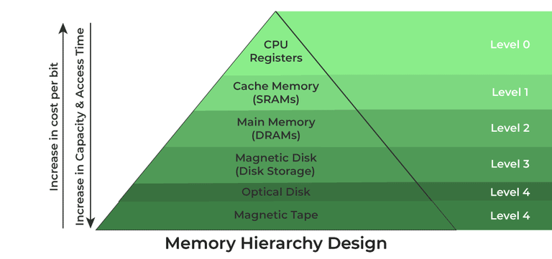
Memory Hierarchy Design

Memory Hierarchy Design

1. Registers
Registers are small, high-speed memory units located in the CPU. They are used to store the most frequently used data and instructions. Registers have the fastest access time and the smallest storage capacity, typically ranging from 16 to 64 bits.

2. Cache Memory
Cache memory is a small, fast memory unit located close to the CPU. It stores frequently used data and instructions that have been recently accessed from the main memory. Cache memory is designed to minimize the time it takes to access data by providing the CPU with quick access to frequently used data.

3. Main Memory
Main memory, also known as RAM (Random Access Memory), is the primary memory of a computer system. It has a larger storage capacity than cache memory, but it is slower. Main memory is used to store data and instructions that are currently in use by the CPU.

Types of Main Memory
- Static RAM: Static RAM stores the binary information in flip flops and information remains valid until power is supplied. It has a faster access time and is used in implementing cache memory.
- Dynamic RAM: It stores the binary information as a charge on the capacitor. It requires refreshing circuitry to maintain the charge on the capacitors after a few milliseconds. It contains more memory cells per unit area as compared to SRAM.

4. Secondary Storage
Secondary storage, such as hard disk drives (HDD) and solid-state drives (SSD), is a non-volatile memory unit that has a larger storage capacity than main memory. It is used to store data and instructions that are not currently in use by the CPU. Secondary storage has the slowest access time and is typically the least expensive type of memory in the memory hierarchy.

5. Magnetic Disk
Magnetic Disks are simply circular plates that are fabricated with either a metal or a plastic or a magnetized material. The Magnetic disks work at a high speed inside the computer and these are frequently used.

6. Magnetic Tape
Magnetic Tape is simply a magnetic recording device that is covered with a plastic film. It is generally used for the backup of data. In the case of a magnetic tape, the access time for a computer is a little slower and therefore, it requires some amount of time for accessing the strip.

Characteristics of Memory Hierarchy
- Capacity: It is the global volume of information the memory can store. As we move from top to bottom in the Hierarchy, the capacity increases.
- Access Time: It is the time interval between the read/write request and the availability of the data. As we move from top to bottom in the Hierarchy, the access time increases.
- Performance: Earlier when the computer system was designed without a Memory Hierarchy design, the speed gap increased between the CPU registers and Main Memory due to a large difference in access time. This results in lower performance of the system and thus, enhancement was required. This enhancement was made in the form of Memory Hierarchy Design because of which the performance of the system increases. One of the most significant ways to increase system performance is minimizing how far down the memory hierarchy one has to go to manipulate data.
- Cost Per Bit: As we move from bottom to top in the Hierarchy, the cost per bit increases i.e. Internal Memory is costlier than External Memory.

Advantages of Memory Hierarchy
- It helps in removing some destruction, and managing the memory in a better way.
- It helps in spreading the data all over the computer system.
- It saves the consumer’s price and time.

Practical:-9
Aim:- Paraphrase Associative Memory in details.
An associative memory can be considered as a memory unit whose stored data can be identified for access by the content of the data itself rather than by an address or memory location.
Associative memory is often referred to as Content Addressable Memory (CAM).
When a write operation is performed on associative memory, no address or memory location is given to the word. The memory itself is capable of finding an empty unused location to store the word.
On the other hand, when the word is to be read from an associative memory, the content of the word, or part of the word, is specified. The words which match the specified content are located by the memory and are marked for reading.
PlayNext
Unmute
Current TimeÂ 0:00
/
DurationÂ 18:10
Loaded: 0.37%
Â
Fullscreen
Backward Skip 10sPlay VideoForward Skip 10s
The following diagram shows the block representation of an Associative memory.
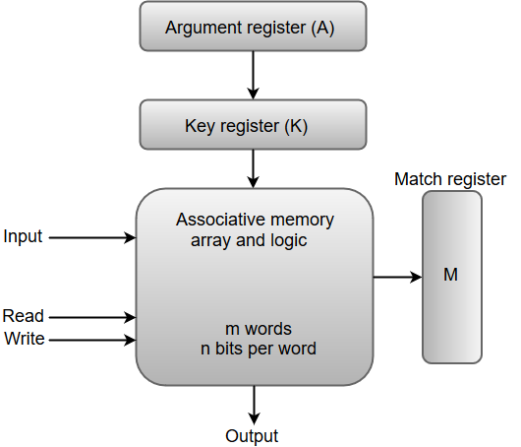
From the block diagram, we can say that an associative memory consists of a memory array and logic for 'm' words with 'n' bits per word.
The functional registers like the argument register A and key register K each have n bits, one for each bit of a word. The match register M consists of m bits, one for each memory word.
The words which are kept in the memory are compared in parallel with the content of the argument register.
The key register (K) provides a mask for choosing a particular field or key in the argument word. If the key register contains a binary value of all 1's, then the entire argument is compared with each memory word. Otherwise, only those bits in the argument that have 1's in their corresponding position of the key register are compared. Thus, the key provides a mask for identifying a piece of information which specifies how the reference to memory is made.
The following diagram can represent the relation between the memory array and the external registers in an associative memory.
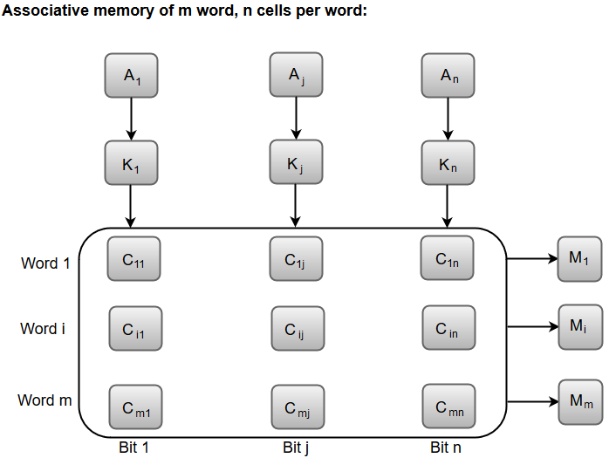
The cells present inside the memory array are marked by the letter C with two subscripts. The first subscript gives the word number and the second specifies the bit position in the word. For instance, the cell C_{ij} is the cell for bit j in word i.
A bit A_{j} in the argument register is compared with all the bits in column j of the array provided that K_{j} = 1. This process is done for all columns j = 1, 2, 3......, n.
If a match occurs between all the unmasked bits of the argument and the bits in word i, the corresponding bit M_{i} in the match register is set to 1. If one or more unmasked bits of the argument and the word do not match, M_{i} is cleared to 0.

Practical:-10
Aim:- Differentiate Programmed I/O and Interrupt initiated I/O in detail.
Data transfer between the CPU and I/O devices can be done in variety of modes. These are three possible modes:
- Programmed I/O
- Interrupt initiated I/O
- Direct Memory Access (DMA)
In this article we shall discuss the first two modes only.
1. Programmed I/O :
In this mode the data transfer is initiated by the instructions written in a computer program. An input instruction is required to store the data from the device to the CPU and a store instruction is required to transfer the data from the CPU to the device. Data transfer through this mode requires constant monitoring of the peripheral device by the CPU and also monitor the possibility of new transfer once the transfer has been initiated. Thus CPU stays in a loop until the I/O device indicates that it is ready for data transfer. Thus programmed I/O is a time consuming process that keeps the processor busy needlessly and leads to wastage of the CPU cycles.
This can be overcome by the use of an interrupt facility. This forms the basis for the Interrupt Initiated I/O.
2. Interrupt Initiated I/O :
This mode uses an interrupt facility and special commands to inform the interface to issue the interrupt command when data becomes available and interface is ready for the data transfer. In the meantime CPU keeps on executing other tasks and need not check for the flag. When the flag is set, the interface is informed and an interrupt is initiated. This interrupt causes the CPU to deviate from what it is doing to respond to the I/O transfer. The CPU responds to the signal by storing the return address from the program counter (PC) into the memory stack and then branches to service that processes the I/O request. After the transfer is complete, CPU returns to the previous task it was executing. The branch address of the service can be chosen in two ways known as vectored and non-vectored interrupt. In vectored interrupt, the source that interrupts, supplies the branch information to the CPU while in case of non-vectored interrupt the branch address is assigned to a fixed location in memory.

Difference between Programmed and Interrupt Initiated I/O :
Programmed I/O | Interrupt Initiated I/O
Data transfer is initiated by the means of instructions stored in the computer program. Whenever there is a request for I/O transfer the instructions are executed from the program. | The I/O transfer is initiated by the interrupt command issued to the CPU.
The CPU stays in the loop to know if the device is ready for transfer and has to continuously monitor the peripheral device. | There is no need for the CPU to stay in the loop as the interrupt command interrupts the CPU when the device is ready for data transfer.
This leads to the wastage of CPU cycles as CPU remains busy needlessly and thus the efficiency of system gets reduced. | The CPU cycles are not wasted as CPU continues with other work during this time and hence this method is more efficient.
CPU cannot do any work until the transfer is complete as it has to stay in the loop to continuously monitor the peripheral device. | CPU can do any other work until it is interrupted by the command indicating the readiness of device for data transfer
Its module is treated as a slow module. | Its module is faster than programmed I/O module.
It is quite easy to program and understand. | It can be tricky and complicated to understand if one uses low level language.
The performance of the system is severely degraded. | The performance of the system is enhanced to some extent.

